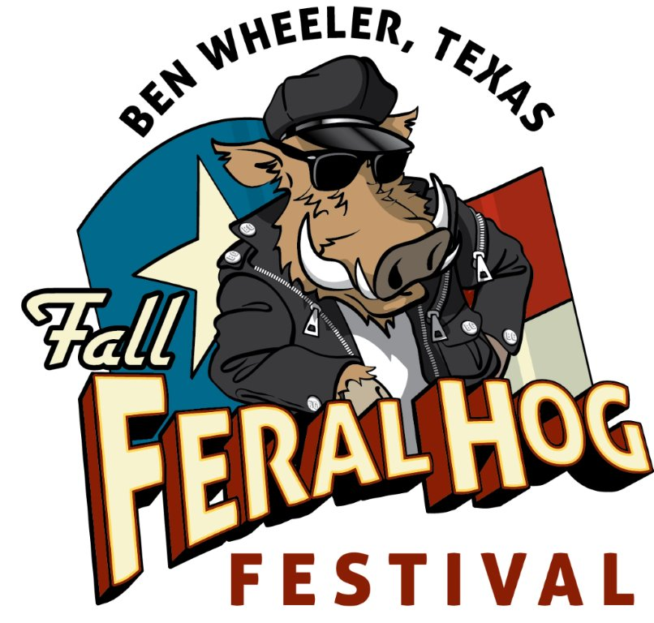
2015 Fall Feral Hog Festival • Ben Wheeler, Texas
Parade PARTICIPANT
Saturday, Oct. 24 • 9 a.m. Line Up •10 a.m. Start
Downtown Ben Wheeler
Official Entry Form
“Gettin’ Piggy With It”

Organization, group or individual’s name (please print)_____________________________________________________________________________

Sponsor______________________________________________________________________ Contact Name_______________________________________________

Address_______________________________________________ City_________________________________________________ State______ Zip_________________

Phone Number____________________________________ Cell: _________________________________ Email___________________________________________

Float Description____________________________________________________________________________________________________________________________

________________________________________________________________________________________________________________________________________________

________________________________________________________________________________________________________________________________________________

________________________________________________________________________________________________________________________________________________

________________________________________________________________________________________________________________________________________________

PLEASE NOTE:
All contestants must be available to participate at 9 a.m. Saturday, Oct. 24. Parade start time is 10 a.m., but we ask float & parade participants to arrive at least one hour prior to allow enough time for set up and line up along the parade route.

Each group or individual’s float officially entered will qualify for the following prizes:

1st Place Float $500 plus plaque
2nd Place Float $300 plus plaque
3rd Place Float $200 plus plaque

PLEASE READ & SIGN RELEASE OF LIABLITY BELOW
By signing and submitting this entry form, I agree to hold harmless Ben Wheeler Development Company, L.L.C, Ben Wheeler Arts & Historic District Foundation, and the 2015 Fall Feral Hog Festival & Parade from liabilities due to accidents, theft, injury, or death while participating in or traveling to or from the parade. I also hereby grant the right to use any photos or videos made during the parade for promotional purposes inclusive of the contestants (Organization, business, group or individual) named on this form. I agree not to dispute any parade decisions and understand that all judge’s decisions are final.

Print Responsible Party’s Name___________________________________________________________ Date_________________________

Responsible Party’s Signature_____________________________________________________________ Date_________________________

SUBMIT OFFICIAL ENTRY FORM TO: Ben Wheeler Arts & Historic District Foundation,
P.O. BOX 7, Ben Wheeler, TX 75754, or drop off at 13814 State Highway 64 in Ben Wheeler.
For more information, call 903.833.1070, email hogfest@bwdc.net, or visit benwheelertx.com.
Deadline for Submission: Friday, Oct. 16, 2015

