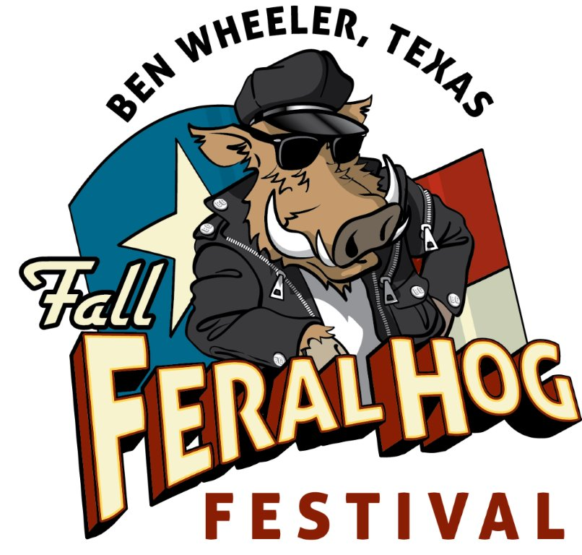
2015 Fall Feral Hog Festival • Ben Wheeler, Texas
HOG QUEEN PAGEANT
Friday, Oct. 23 • 7p.m. at Moore’s Store
Queen & Court Presentation Sat., Oct 24, 11a.m, Pickin Porch

Official Entry Form
Note: The Hog Queen Pageant is for FUN! It is not about beauty or real talent, or any of the traditional qualities often found in a "serious" pageant. Rather, what we look for is someone with a "Mardi Gras" spirit and attitude to fit with the fun and quirky nature of the Fall Feral Hog Festival. With that in mind, we hope you will join us!

Contestant’s Name (please print)_________________________________ D.O.B. or Age____________ _____Male _____Female

Address_____________________________________________________ City____________________________ State_____ Zip_____________

Phone Number___________________________ Cell _________________________________ Email____________________________________

What qualifies you to hold the title of Hog Queen? ______________________________________________________________________________
________________________________________________________________________________________________________________________
________________________________________________________________________________________________________________________

What are your hobbies, special interests or talents? ______________________________________________________________________________
________________________________________________________________________________________________________________________

During the pageant, contestants are required to perform a talent on stage before a panel of judges. What talent do you plan on performing? Please be specific.
________________________________________________________________________________________________________________________
________________________________________________________________________________________________________________________
PRIZES:
- WINNER: $500 and a Crown
- RUNNER-UP: $250

PLEASE NOTE:
• Contestants must be 18 years old or older, male or female, and have your own transportation.
• All contestants must provide their own costume or Hog Queen attire for the Pageant and the Court Presentation.
• All contestants must be able to attend both the Pageant/Coronation on Friday, Oct. 23 at 7 p.m., as well as the Presentation of the Court the day of the Fall Feral Hog Festival, Saturday, Oct. 24 from 10 a.m. to 4 p.m.
• Contestants must be able to appear as needed at various events throughout the year to represent Ben Wheeler.

PLEASE READ & SIGN RELEASE OF LIABLITY
By signing and submitting this entry form, I agree to hold harmless Ben Wheeler Development Company, LLC, Ben Wheeler Arts & Historic District
Foundation, and the 2015 Fall Feral Hog Queen Pageant from liabilities due to accidents, theft, injury, or death while participating in or traveling to
or from the pageant or other appearances. I hereby grant the right to use any photos or videos made during the pageant for promotional purposes inclusive of the contestants name provided on this form. I agree not to dispute any pageant decisions and understand that all judges’ decisions are final.

Print Name___________________________________________________________ Date___________________________________

Signature_____________________________________________________________ Date__________________________________

SUBMIT OFFICIAL ENTRY FORM TO: Ben Wheeler Arts & Historic District Foundation
P.O. BOX 7, Ben Wheeler, TX 75754, or deliver to 13814 State Highway 64 in Ben Wheeler
Deadline for submission: Friday, Oct. 16, 2015

For more information, call 903.833.1070, email hogfest@bwdc.net or visit benwheelertx.com

