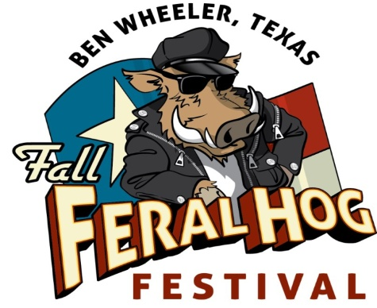

2015 Fall Feral Hog Festival • Ben Wheeler, Texas
Saturday, Oct. 24 • Ben Wheeler Festival Grounds

NOTE: There are a limited number of spaces available and vendors will be chosen based on how well they fit the festival’s atmosphere.

❏ Food ❏ Craft VENDOR APPLICATION

Company Name (please print)_________________________________________________ Contact Name___________________________________________

Address_______________________________________________ City_________________________________________________ State______ Zip_________________

Phone Number____________________________________ Cell: _________________________________ Email___________________________________________

Describe your merchandise/service: _____________________________________________________________________________________________________
_______________________________________________________________________________________________________________________________________________

SPACE SIZE: 10 feet x 10 feet. Be sure to indicate if you wish to reserve more than one space. Vendors must be set up and ready by 9:30 a.m. Saturday, October 24 and remain set up until 4 p.m. You will need to bring your own tents, tables and chairs.

SPACE PRICE: $150 per 10x10 space. Add $10 per space for electricity.

Once your application is approved, make checks payable to Ben Wheeler Arts & Historic District Foundation. Make sure checks or money orders have your phone number on it.

Send check to P.O. Box 7, Ben Wheeler, TX, 75754, or drop off at 13814 State Highway 64 in Ben Wheeler

FOOD VENDORS: Food vendors must attach a copy of a valid permit from the department of health.

VENDOR RULES: Vendors shall conduct business from within the confines of their assigned space. Vendors are required to keep their spaces neat and attractive and pick up their own trash. No unsupervised children, loud music, offensive noise, or distractions are permitted.

PLEASE READ & SIGN RELEASE OF LIABLITY BELOW:

By signing and submitting this entry form, I agree to hold harmless Ben Wheeler Development Company, L.L.C, Ben Wheeler Arts
& Historic District Foundation, and the 2015 Fall Feral Hog Festival & Parade from liabilities due to accidents, theft, injury, or death
while participating in or traveling to or from the festival. I also hereby grant the right to use any photos or videos made during the
festival for promotional purposes inclusive of the vendors (Organization, business, group or individual) named on this form.

Print Responsible Party’s Name___________________________________________________________ Date_________________________

Responsible Party’s Signature_____________________________________________________________ Date_________________________

SUBMIT VENDOR APPLICATION TO: Ben Wheeler Arts & Historic District Foundation,
P.O. BOX 7, Ben Wheeler, TX 75754, or deliver to 13814 State Highway 64 in Ben Wheeler.

Deadline for Applications: Friday, Oct. 16, 2015
Must pay by this date.
For more information, call 903.833.1070, email hogfest@bwdc.net, or visit benwheelertx.com.

